***Pronouncing / Θ /***

*Pronunciation*

Private Tutoring

Mouth Formation

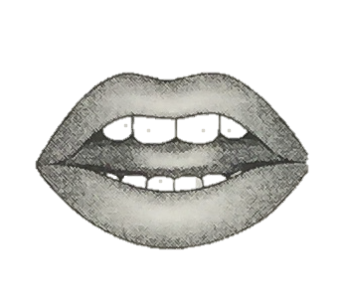

To make / *Θ* /:

1. Put the tip of your tongue between your teeth
2. Push air between your teeth and tongue
3. Don’t use your voice: / *Θ* / is unvoiced

*\* Tips: if you…*

* *put your hand in front of your mouth while making this sound 🡪*

*you should feel air on your hand*

* *put your fingers on your throat while you’re making this sound 🡪*

*you should NOT feel vibration in your throat*

*Be careful! / Θ / should not sound like / s / or / f / or / t / look at the difference:*

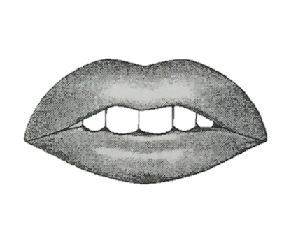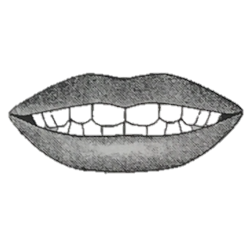

/ Θ / / s / / f /

Spelling

|  |
| --- |
| Th |
| * Thanks * Thing * Author |

Exceptions

Even though you may see a [th] spelling doesn’t mean you’ll have a / Θ / sound

* Pronounce the [th] in clo**th**, but don’t pronounce the [th] in clo~~th~~es.

Clo~~th~~es is pronounced like the verb *close*.

* Pronounce the [th] in **Th**ai and **T**hailand with a / t / sound
* When words ending in a [th] have an –s ending the final / Θ / is often simplified or dropped and the–s ending lengthened:
  + One mon**th**—two mon~~th~~**s** {monss}
  + One-fif**th**—two-fif~~th~~s {fifss}
* If your word is a noun you probably pronounce like / *Θ* / (bath, breath)

If your word is a verb you probably pronounce like / ð / (bathe, breathe)

Practice

|  |  |  |
| --- | --- | --- |
| Beginning of Words | Middle of words | End of words |
| * Thank you * Thankful * Thankless * Thanks * Thanksgiving * Thaw * Theatre * Theme * Theory * Therapy * Thermos * Thesaurus * Thick * Thief * Thigh * Thimble * Thin * Thing * Think * Third * Thirsty * Thirteen * Thirty * Thistle * Thorn * Thorough * Thought * Thousand * Thread * Three * Throat * Throw * Through * Thumb * Thunder * Thursday | * 7:30 * Anything * Athlete * Authentic * Author * Authority * Authorize * Bathroom * Bathrobe * Bathtub * Birthday * Breathless * Empathy * Ethics * Everything * Healthy * Hypothetic * Marathon * Mathematics * Method * Mouthwash * Nothing * Panther * Pathetic * Pathway * Python * Rethink * Something * Sympathize * Toothache * Toothbrush * Toothpaste * Toothpick * Truthful * Youthful * Wealthy | * Aftermath * Bath * Beneath * Booth * Both * Breath * Broth * Cloth * Death * Earth * Eighth * Eightieth * Elizabeth * Fifth * Growth * Math * Month * Moth * Mouth * Ninth * North * Oath * Path * Smith * South * Strength * Teeth * Tenth * Tooth * Truth * Underneath * With * Worth * Wreath * Youth |

Minimal Pairs

*Listen for the difference. Then repeat:*

|  |  |  |  |
| --- | --- | --- | --- |
| Θ & s | | | |
| A: Math  B: Mass | A: Thing  B: Sing | A: Bath  B: Bass | A: Thin  B: Sin |
| A: Think  B: Sink | A: Tease  B: Teeth | A: Worth  B: Worse |  |
| Θ & t | | | |
| A: Three  B: Tree | A: Thin  B: Tin | A: Thanks  B: Tanks | A: With  B: Wit |
| A: Bath  B: Bat | A: Thinker  B: Tinker |  |  |
| Θ & f | | | |
| A: Author  B: Offer | A: Three  B: Free | A: With  B: Whiff |  |

*Say Word A or Word B. Your listener will tell you which letter your said.*

Phrases

*Read the following sentences and pronounce / Θ / correctly:*

1. The fourth Thursday of November is American Thanksgiving.
2. A “thingamajig” is something whose real name you can’t think of.
3. Three hundred and thirty-three thousand therapists thought about the new theory of thinking.
4. The thieves threatened three dozen Southern mothers.
5. The theme seems thoughtless to them.
6. The data breach affected thirty-three thousand people.
7. Those theatres are nicer.
8. They experience some pretty threatening weather down there.
9. Birth and death are natural processes.
10. Lets do something together.
11. May is the fifth month of the year.
12. It’s worth a thousand dollars
13. I was with you on my twentieth birthday…
14. Anne Frank was a very thoughtful author.
15. Summer thunderstorms threaten the three thick but sick trees.
16. She left a thank you note on the computer.
17. I have hot chocolate in my thermos.
18. I like to eat thick steaks.
19. He is a car thief.
20. His thigh was sore from working hard.
21. We asked for thinly sliced roast beef.
22. She goes to the park to think.
23. Today is her third birthday.
24. The boy was thirsty after running.
25. My address is 13 Park Place.
26. She turned thirty in May.
27. The rose bush has a sharp thorn on it.
28. Will you grab the blue thread?
29. She hung a three on the side of her house.
30. She gave him a thumbs up.
31. I put a thumbtack on the map.
32. The thunder was loud.
33. The party is on Thursday night.
34. The athlete entered the high jump event.
35. The author mostly wrote mysteries.
36. My bathrobe is nice and soft.
37. She wanted to clean her bathtub.
38. He invited his friends to his birthday party.
39. He ran so much he was breathless.
40. The earthquake destroyed the road.
41. They are eating healthy food.
42. Mouthwash makes your mouth feel fresh.
43. There is nothing in his pockets.
44. Her toothache was painful.
45. The dentist gave her a new toothbrush.
46. Toothpaste will help keep your teeth clean.
47. I’m leaving on the 15th.

Activity

*Answer the following questions. All answers have the / Θ / sound:*

1. What’s an unlucky number? Three
2. What’s 10 x 3? Thirty
3. What’s the opposite of unhealthy? Healthy
4. What’s the opposite of thick? Thin
5. Which continent is Canada a part of? North America
6. How much is 10 + 3? Thirteen
7. On your hand, you have 4 fingers and one… Thumb
8. What do you say when someone does something nice for you? Thanks
9. What do you call the top part of your leg above your knee? Thigh
10. The word dead is an adjective. What is the noun form? Death
11. How much is $1,000 x 3? Three Thousand Dollars
12. What day comes after Wednesday? Thursday
13. Where do you go to see a new movie? Theatre
14. What’s the opposite of north? South
15. What is the name for the white things in your mouth? Teeth
16. What’s the name for the day you were born? Birthday
17. What part of your face is under your nose? Mouth
18. What is January? Month
19. What’s a word that means “a way of doing something”? Method
20. Someone who writes a book is an… Author

Speaking

*Answer the following questions:*

1. When’s your birthday?